**Microbit + soil moisture calibration lab Instructions:**

In this lab we will setup a Microbit and a soil moisture sensor to feed data into our raspberry Pi. We will then take 3 readings with the sensor in order to see what readings we get when the sensor is completely dry, when it is completely wet and when it is in damp soil.

Plug your micro bit into the top black USB port of your raspberry Pi:

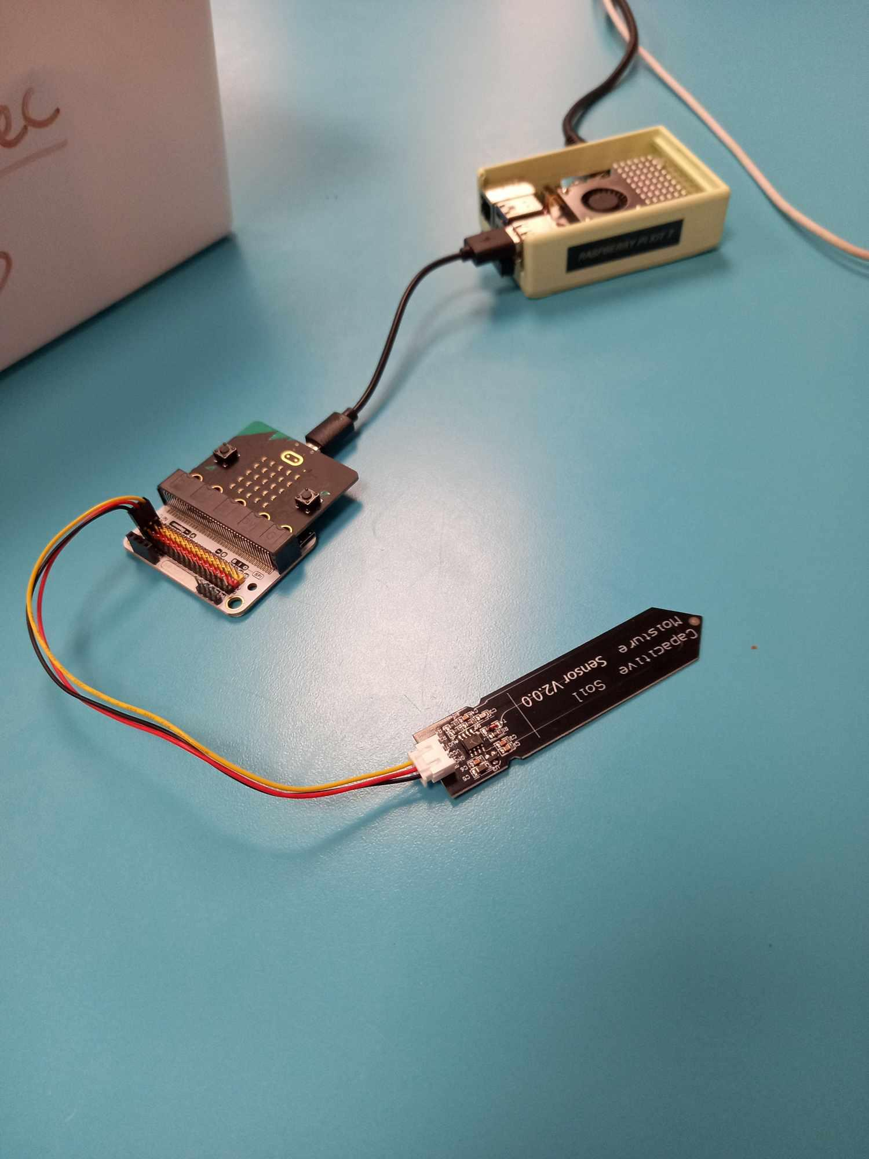

**Setting up Microbit to send data:**

On your Raspberry Pi go to:

<https://makecode.microbit.org/>

Create a new microbit project

Connect your Microbit to the code editor like so:  
  
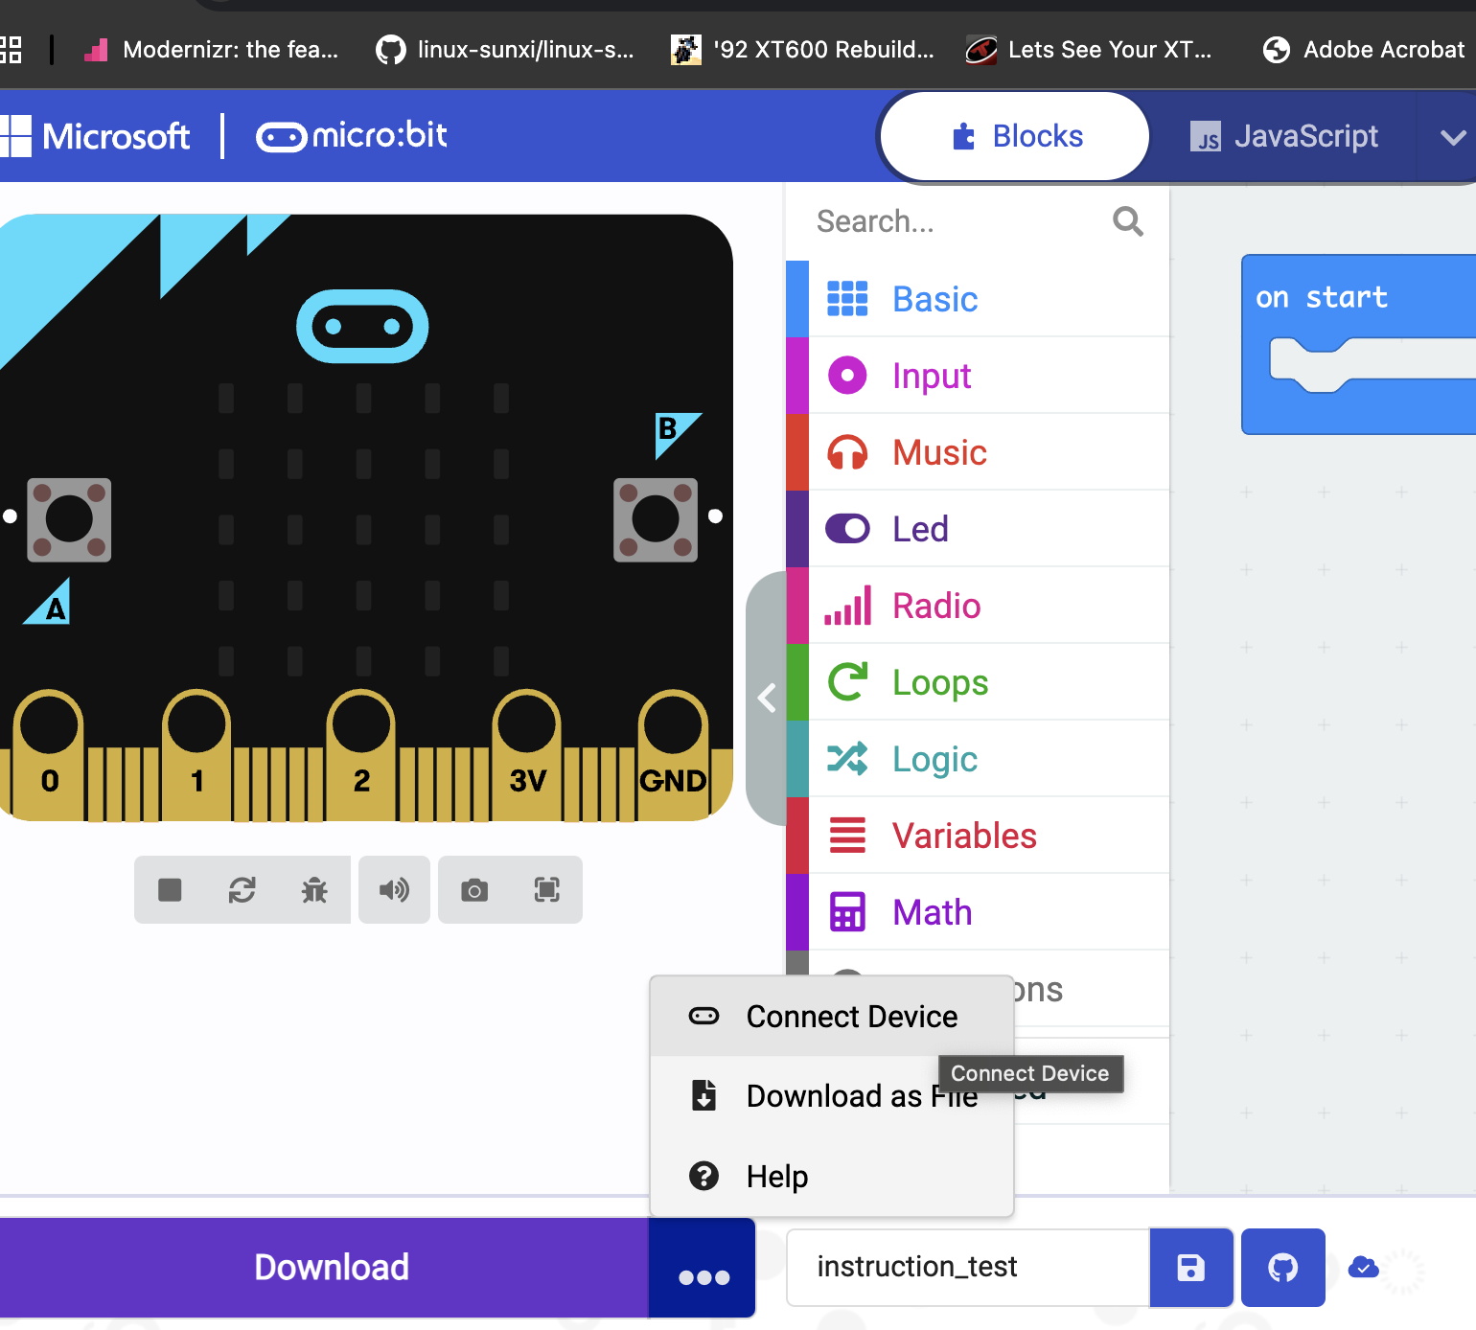

Switch the code from block coding to python like so:  
  
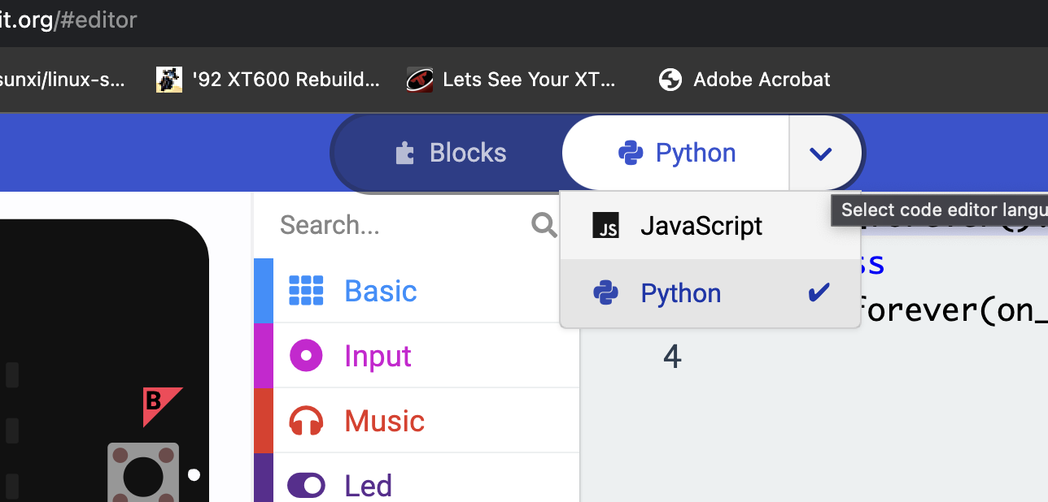

From there you should paste in the “send_data_from_microbit.py” code

<https://github.com/sinclairsystems/microbit_pi_sensor_coms>

You can then download that code onto your Microbit from the code editor.

**Setting up your Pi to receive and present data through a flask website:**

Open up Thonny, create a new file and paste in the “read_microbit_soilMoisture_only.py” code. From this link:  
  
<https://github.com/sinclairsystems/microbit_pi_sensor_coms>

This will allow your Pi to receive the data being sent from the Microbit .

**Taking 3 readings from your soil moisture probe:**  
  
Probe in open air:

Probe in water:

Probe in soil:

**Tricky tasks:**  
  
Remember your OG flask web panel you created? Can you get the data from your soil moisture probe feeding into that flask program?

Can you also rig up and code a DHT11 sensor to read air moisture level?